Agregar projecto que ya existe

Descawrgar repositorio webdrivermanager / isnertar dependencia selenium /

Project –cleans

<https://github.com/bonigarcia/webdrivermanager>

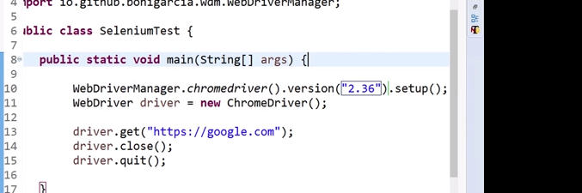

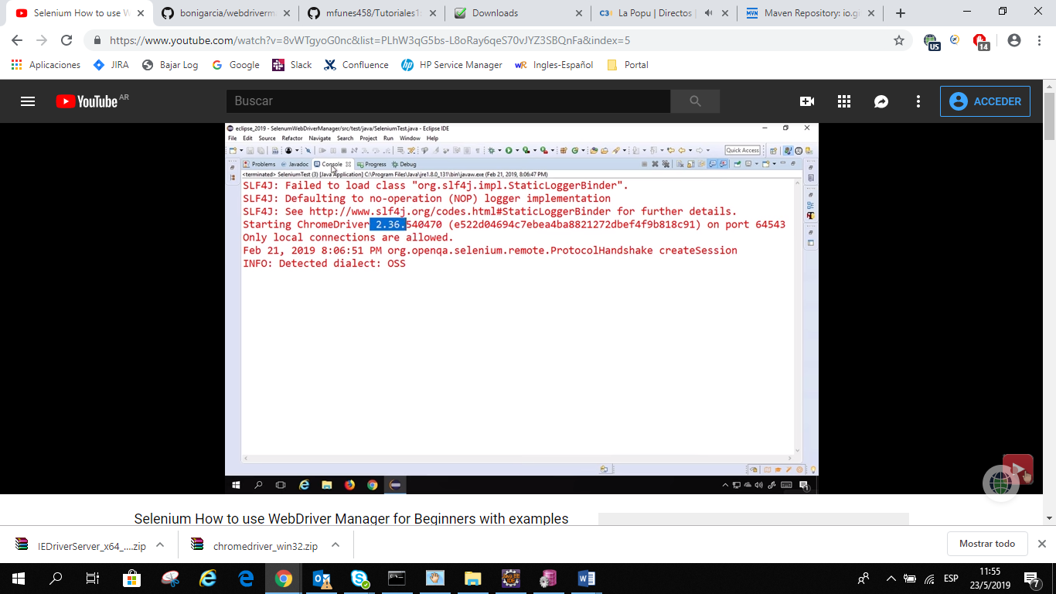

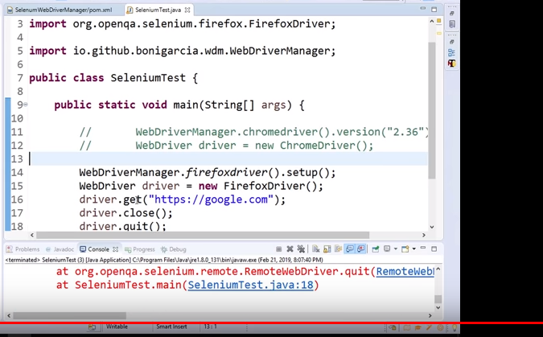

Agregar un proyecto que ya existe, combox

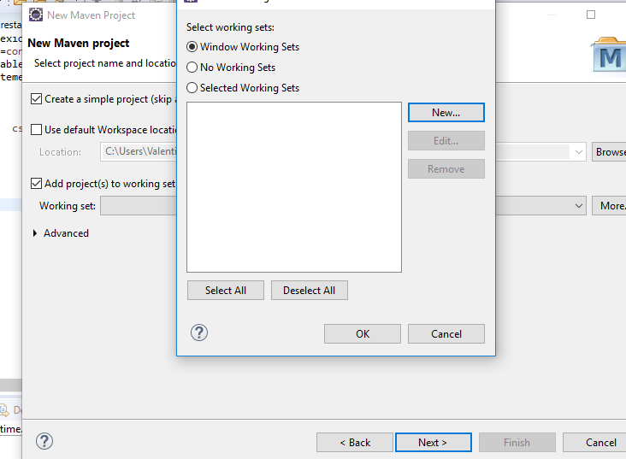

Hi, I am Raghav & today we will learn:

What is WebDriver Manager

How to use WebDriver Manager

A small sample project for demo

WebDriverManager.chromedriver().setup();

WebDriverManager.firefoxdriver().setup();

WebDriverManager.operadriver().setup();

WebDriverManager.phantomjs().setup();

WebDriverManager.edgedriver().setup();

WebDriverManager.iedriver().setup();

<https://github.com/bonigarcia/webdrivermanager>

<https://mvnrepository.com/>

HIT SUBSCRIBE & BELL TO GET NEW VIDEOS

JOIN me on this educational journey as a member and get exclusive perks - Click the JOIN button

https://www.youtube.com/channel/UCTt7...

ONLINE COURSES TO LEARN

<https://www.youtube.com/channel/UCTt7pyY-o0eltq14glaG5dg/join>

<https://automationstepbystep.com/online-courses/>